Experiment No: 3

Exploratory Data Analysis (EDA) – Data Cleaning and Data Transformation

Aim
To identify and handle missing values, duplicate records, outliers, and inconsistent data in the KaggleV2-May-2016.csv dataset, and perform data transformation techniques such as normalization and encoding using Python Pandas and Scikit-Learn.

Algorithm
- Import the required Python libraries.
- Load the KaggleV2-May-2016.csv dataset.
- Identify and count missing values using isnull().
- Handle missing values using suitable methods such as fillna().
- Identify duplicate records using duplicated().
- Remove duplicate records using drop_duplicates().
- Detect outliers using the Interquartile Range (IQR) method.
- Normalize numerical columns using MinMaxScaler.
- Encode categorical columns using Label Encoding.
- Apply One-Hot Encoding where necessary.
- Display the cleaned and transformed dataset for further analysis.

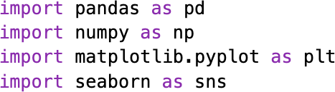



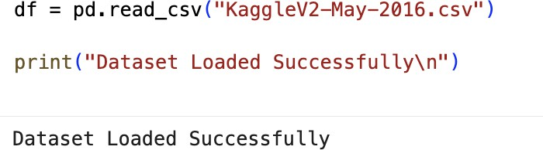

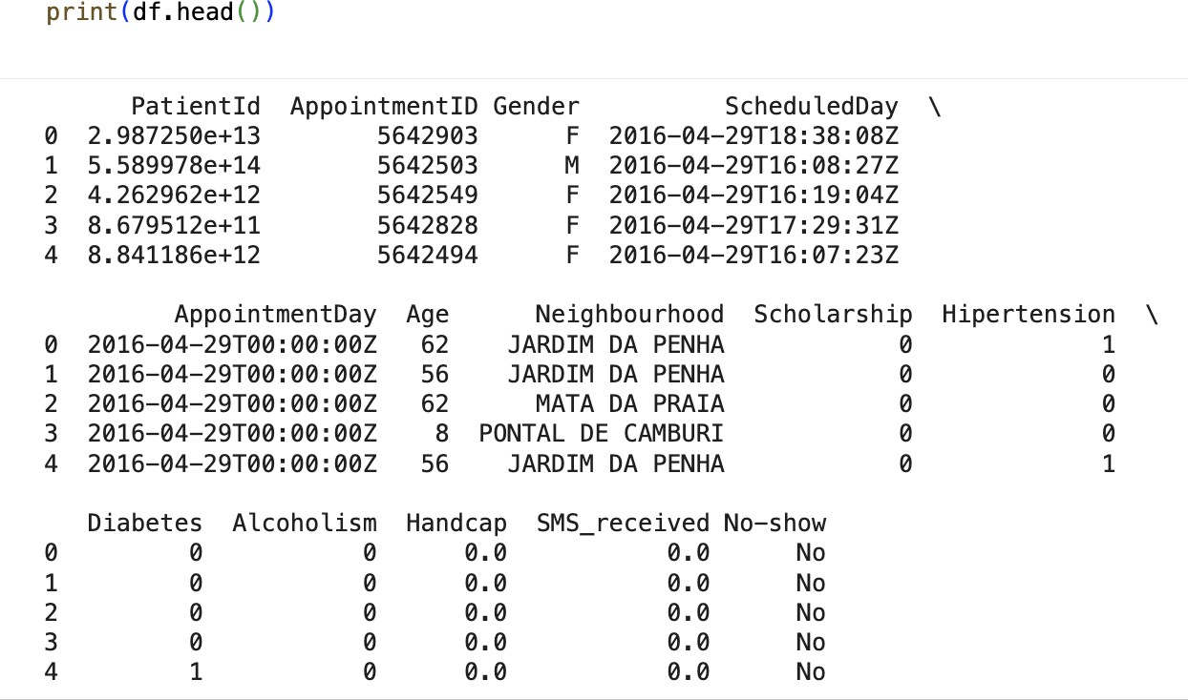

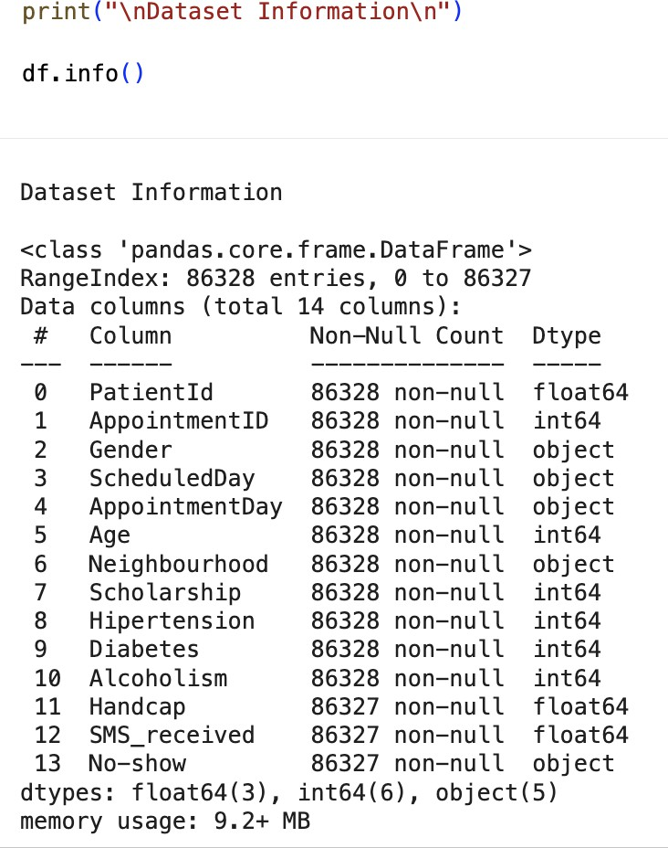

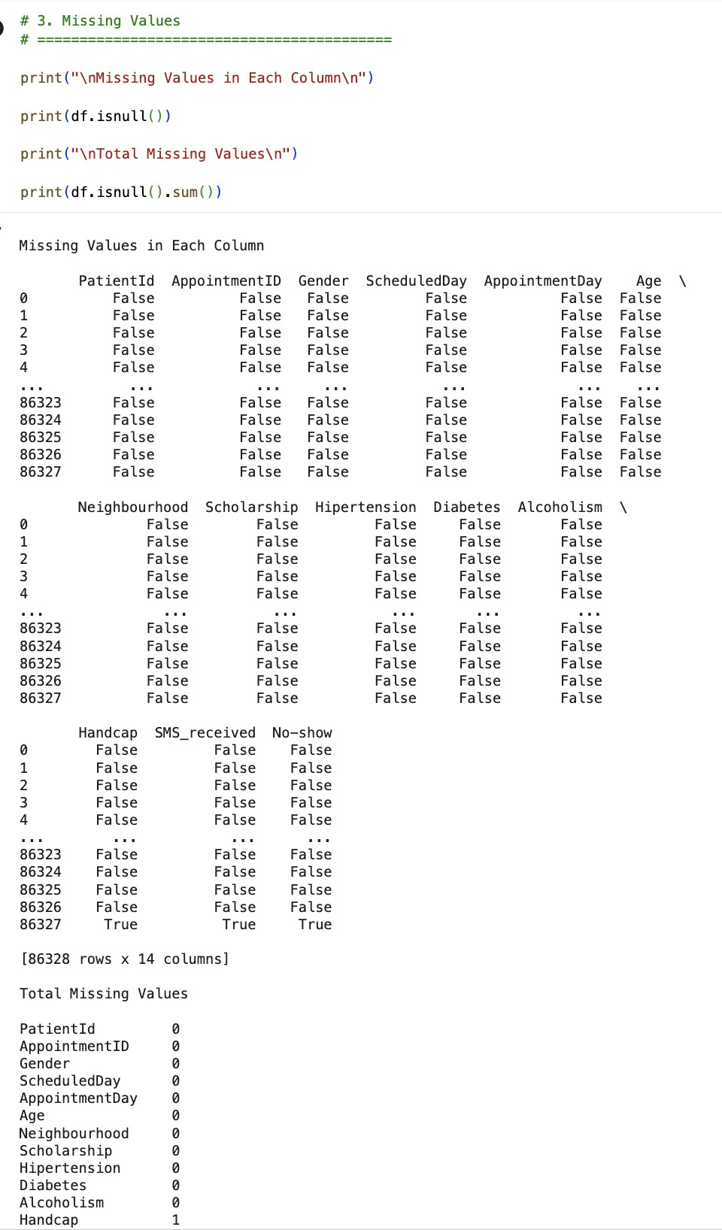

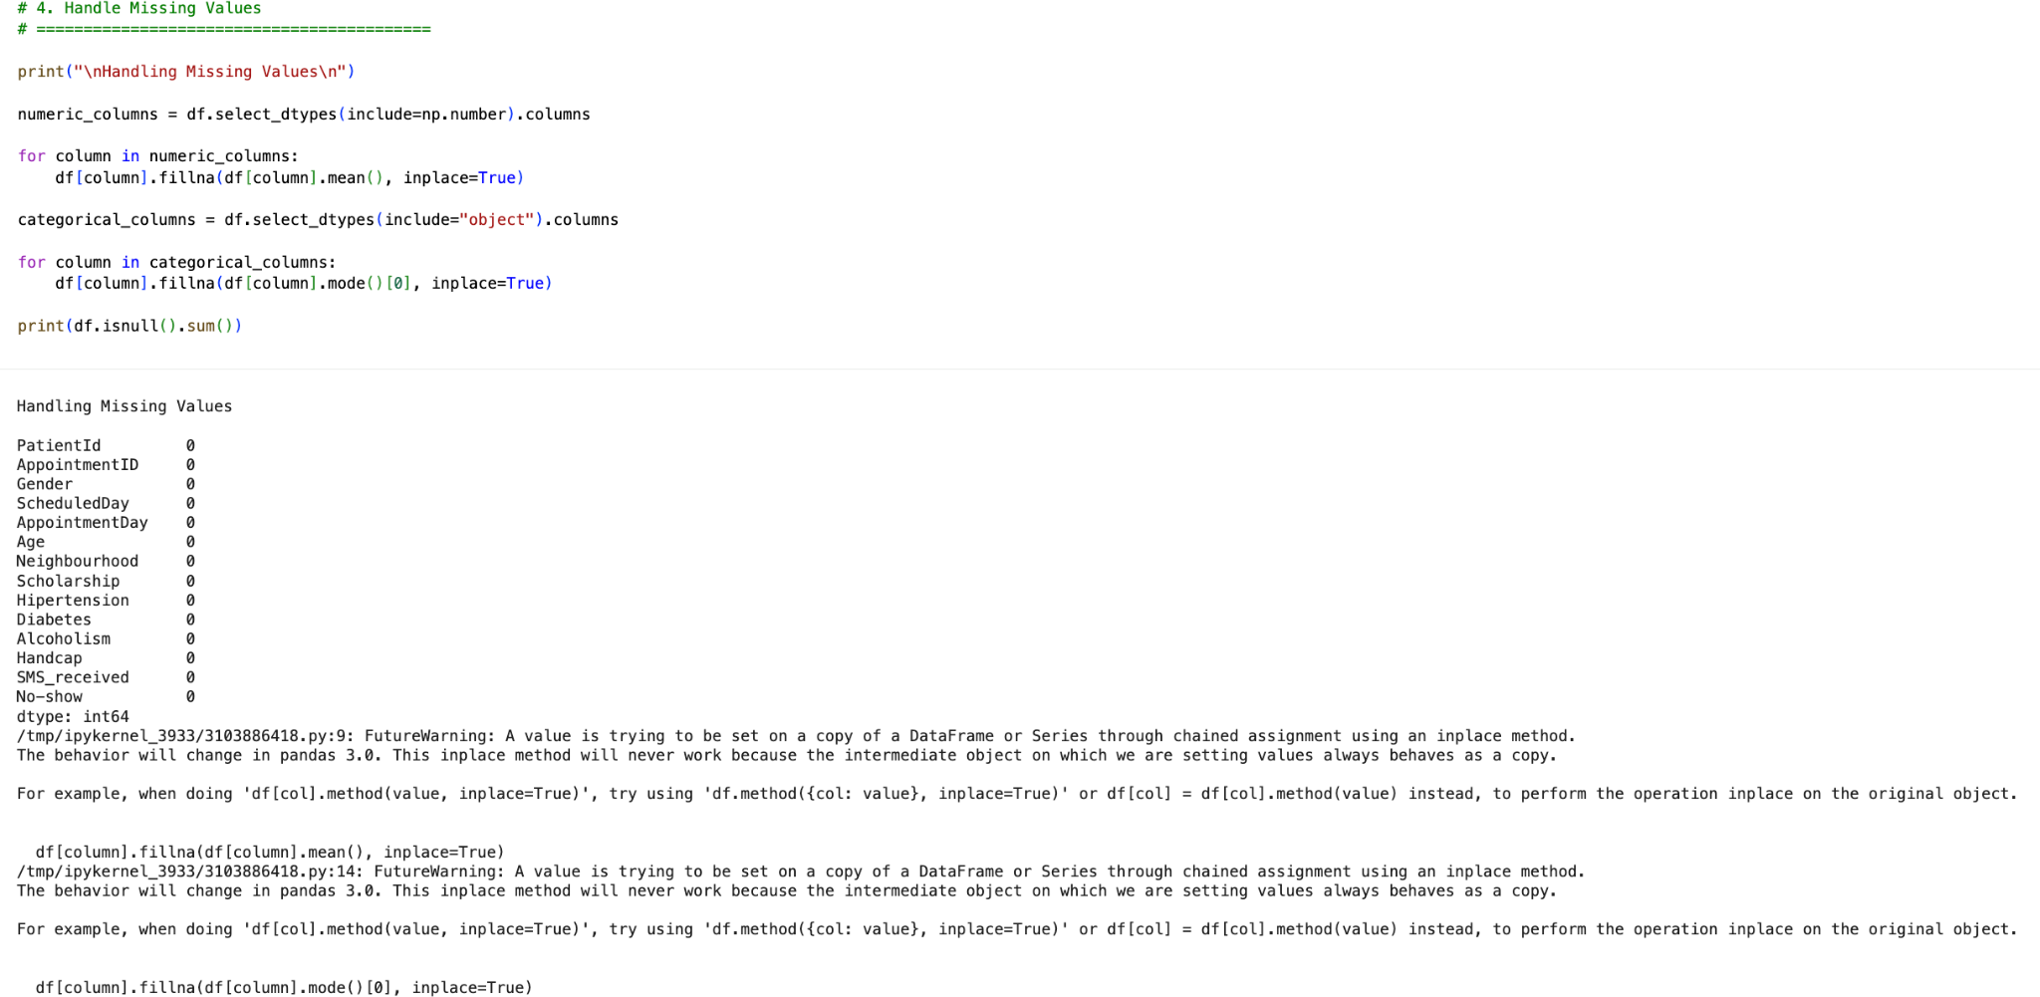

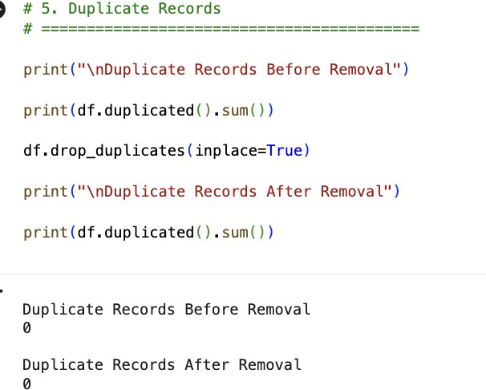

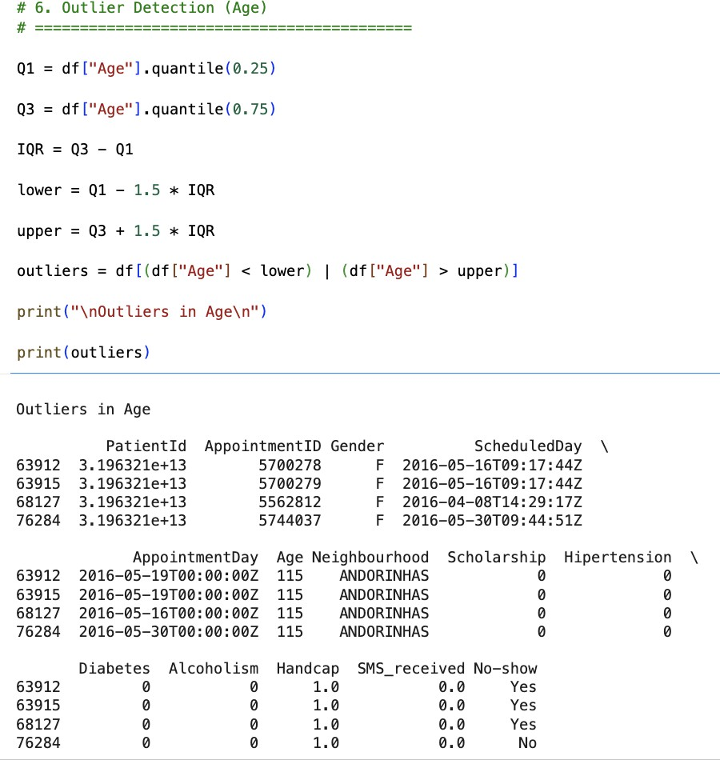

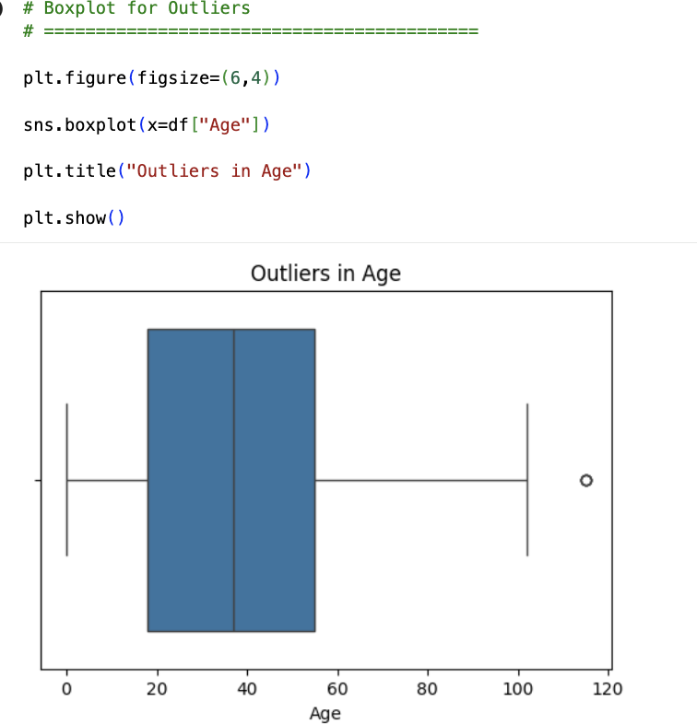

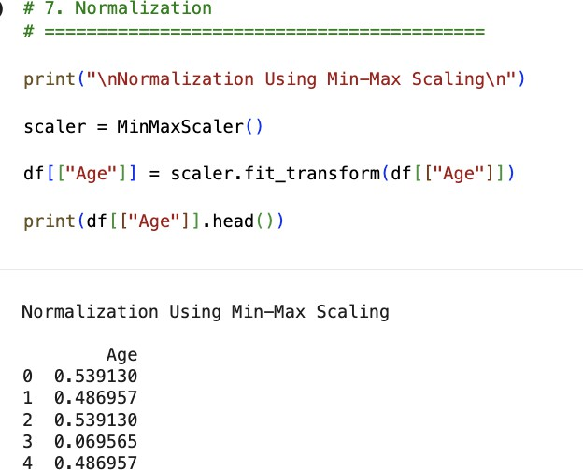

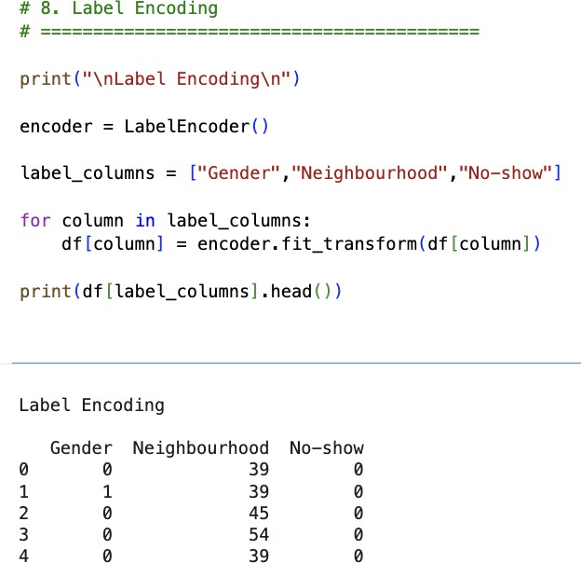

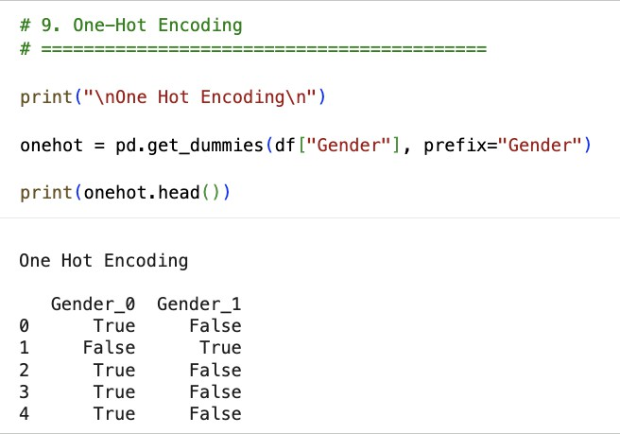

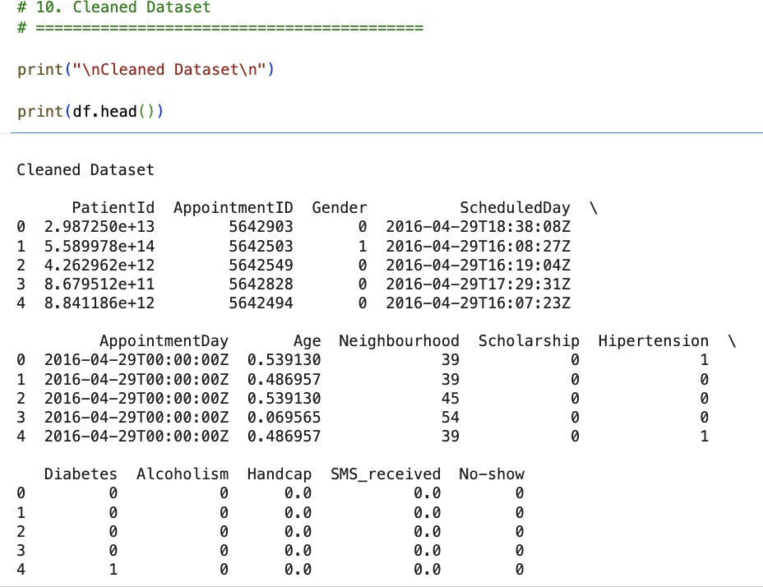

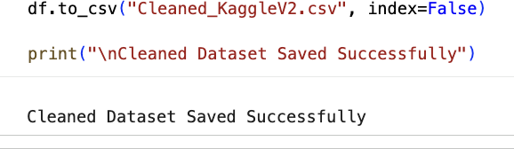

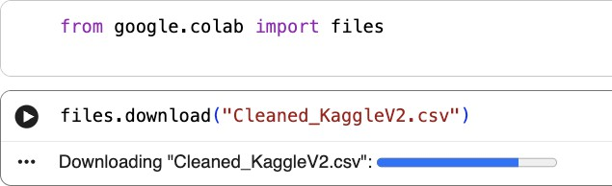

Result
- Thus, missing values, duplicate records, and outliers in the KaggleV2-May-2016.csv dataset were successfully identified and handled. Data transformation techniques such as normalization, label encoding, and one-hot encoding were performed successfully, preparing the dataset for further exploratory data analysis and machine learning applications.

